Summit Careers Content DRAFT

[feature visual text box]

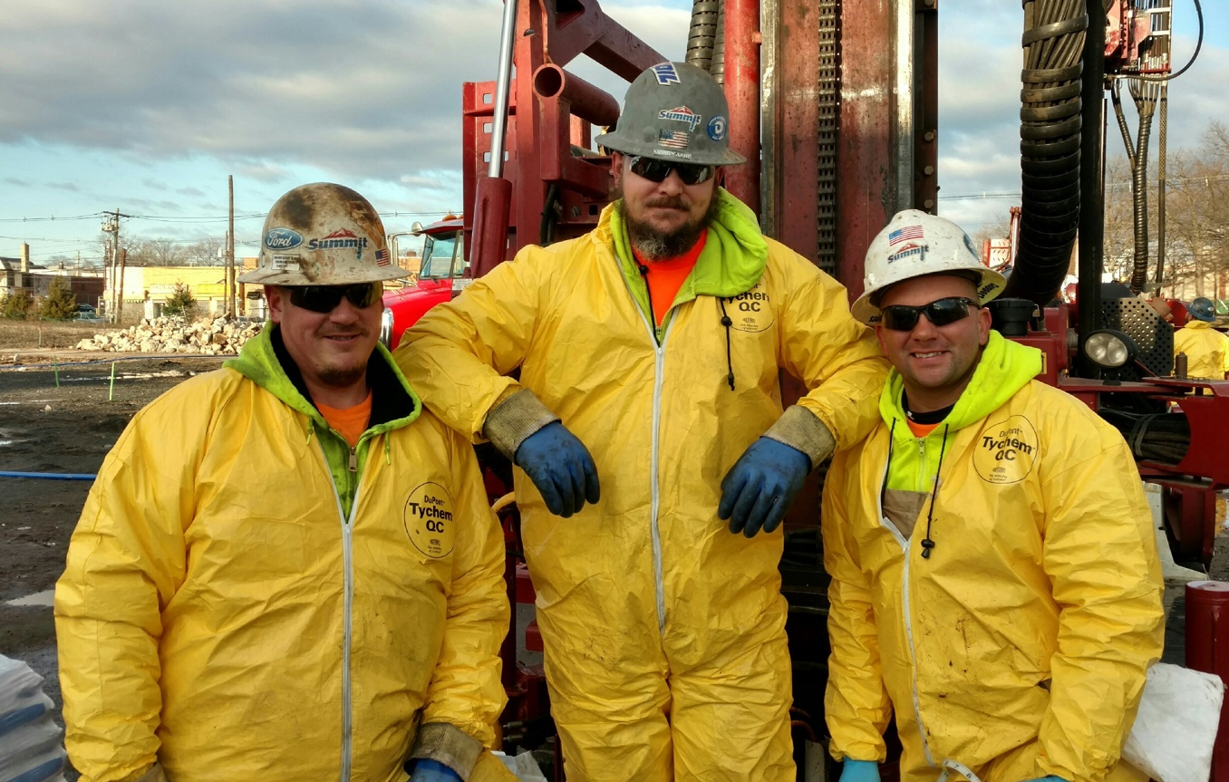
You Matter Here
We enthusiastically welcome new talent to the Summit team and treat all, new members and long-standing contributors, with respect.

[Light green content well]

A Culture of Service. What we promise:

We listen with patience and empathy. Our goal is to be responsive and to follow up in a timely manner to your questions with the answers you need. From understanding details about our comprehensive benefits, to building your career direction, we are here to support you.

We invite open discussion to establish a full understanding of your goals, needs or situations. We will be accessible for you and provide an open door to revisit conversations to ensure a mutual understanding and a positive path forward.
At Summit, you are our customer

[Dark green content well]

What we expect from ourselves and from you
Working together effectively requires professionalism in personal conduct and effort – being forthcoming and transparent is key. Unintentional mistakes should be an opportunity for learning and improvement if discussed honestly. They can be, and should be, a big part of learning and advancement.

We expect our conversations to be civil and supported by the truth. We are all human and susceptible to bad days. When cooler heads prevail, we can create a clear shared understanding and strive towards consistently positive outcomes.

[Additional Content Shortcut Links]

Benefits

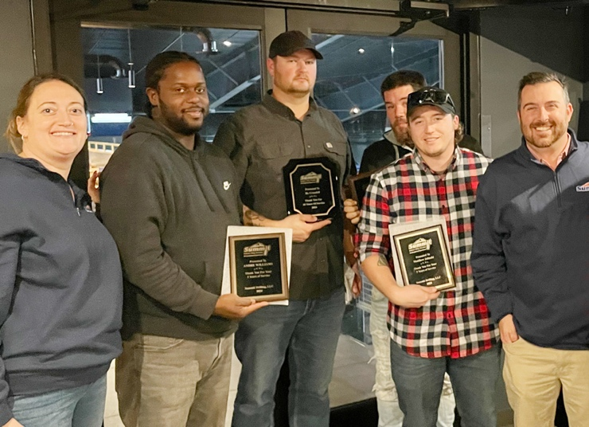

More than great benefits – it’s a great place to belong
Companies talk about taking care of their people all of the time.
At Summit, it’s about teamwork. It’s a company value and how we work every day.

Our benefits wrap around you!
READ MORE >>

Your Career

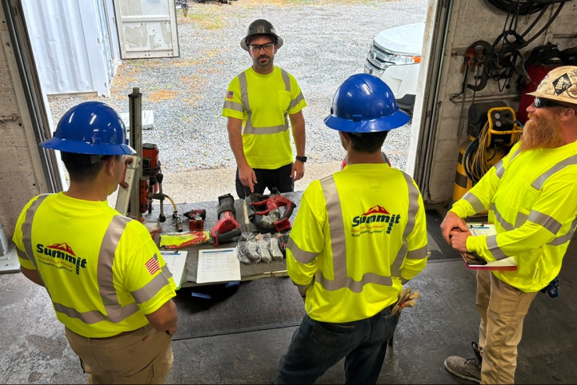
A Path to growth

Training. Development. Mentorship.
Your Opportunity. Your path. Let’s walk it together!
LEARN MORE >>

Positions

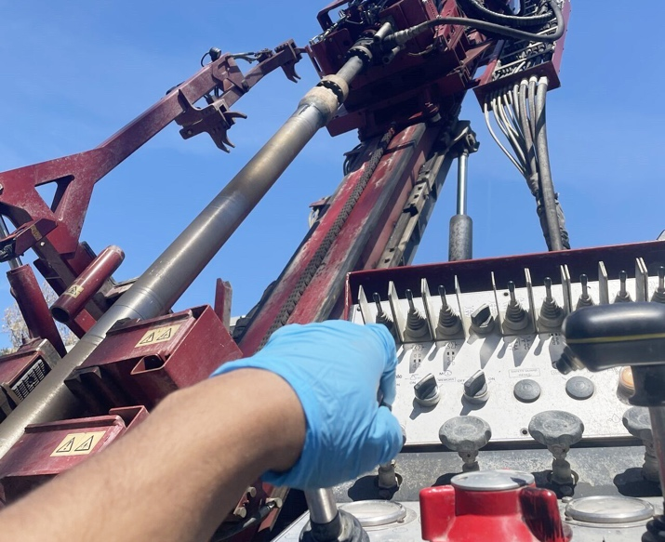

Company-wide Opportunities

Summit has open positions across all service lines and within our office administration.
Learn what’s needed now!

Open Positions >>

Summit’s Vice President of Human Resources Philip Valensi is a dedicated and experienced career-building advocate. Reach out to Philip at 800-242-6648 to discuss your career path at Summit. Or email your resume to Employment@SummitDrilling.com and he will reply promptly.

[EOE]
Equal Opportunity Employer

As an equal opportunity employer, Summit Drilling is committed to fostering a diverse work environment where our team members respect one another and share a commitment to our company’s values, mission, and strategies. Summit Drilling provides equal employment to all team members without regard to race, color, religion, gender, national origin, age, disability, sexual orientation, veteran, or marital status.

[Company Benefits Landing Page]

Join an industry leader experiencing explosive growth. Become part of a culture dedicated to providing you with an opportunity to an exceptional career

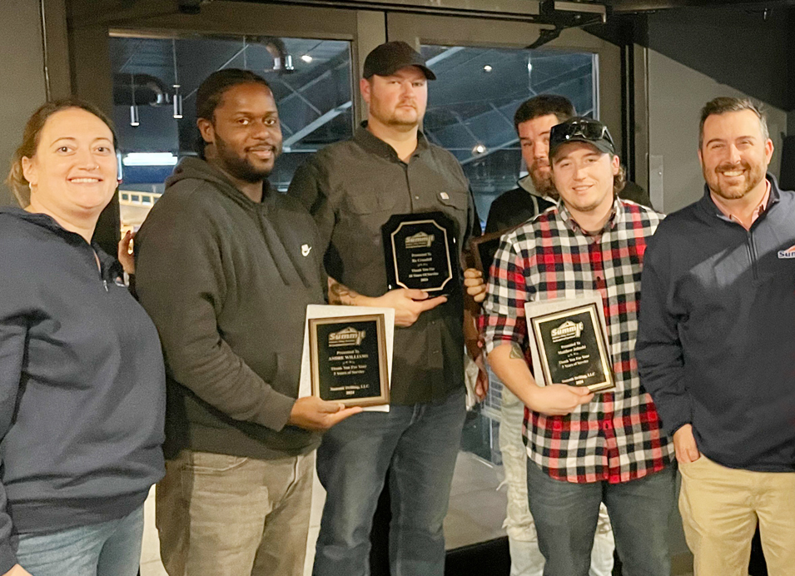

At Summit, people are more than their job titles, they’re valued members of a close-knit team that looks out for one another. New team members quickly discover a culture built on respect, collaboration, and genuine support. That’s why so many of us reach anniversary milestones.

Summit is a growing industry leader offering competitive compensation, a 401(K)-retirement plan, including a generous employer match, healthcare benefits, including dental and vision, a values-based and team-oriented work culture, skills and training development.

Have questions? Reach out to our Vice President of Human Resources, Philip Valensi at 800-424-6648 or email your resume to Employment@SummitDrilling.com

Learn more about our current open positions >>

[Your Career Path Landing Page]

What separates Summit Drilling from our competitors and makes us a highly desired place to build a career, is our company culture and the many talented people who sustain it

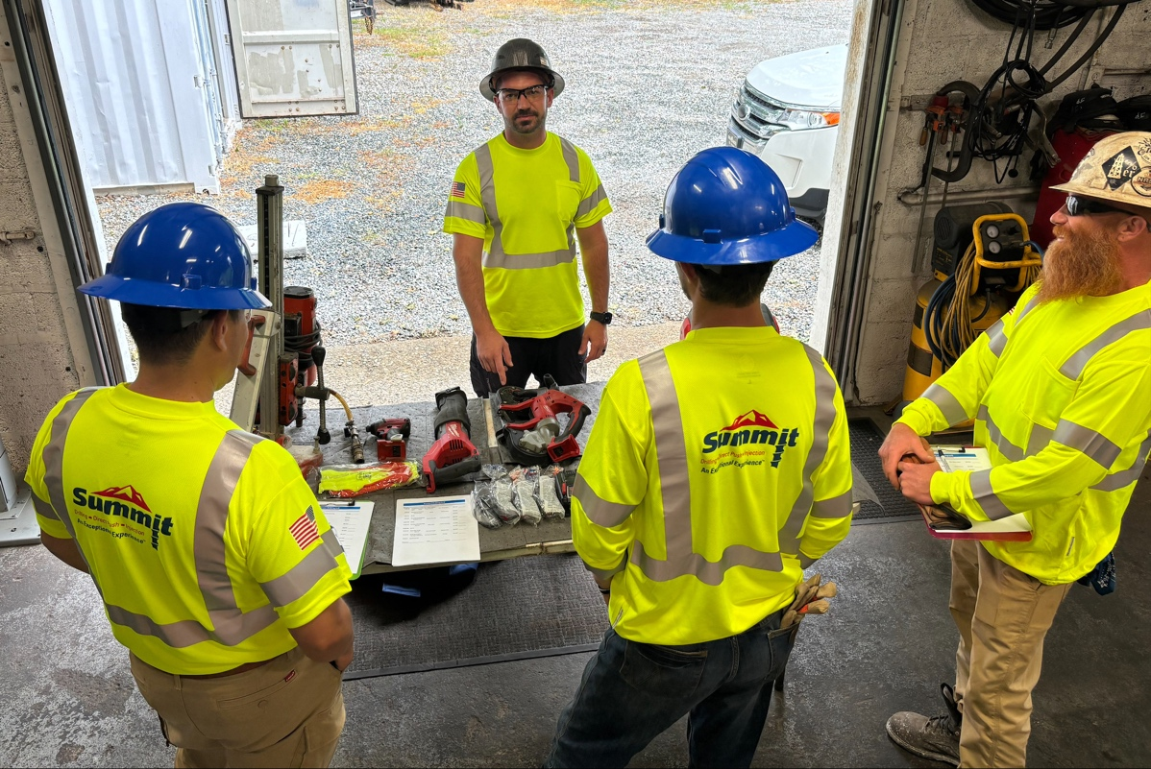

Summit always welcomes the best and brightest and we are committed in training and developing the next wave of Summit team members. We welcome talented individuals who are just starting out to people with some work experience from related fields, such as engineering, construction, manufacturing, auto mechanics, farming, as well as military veterans re-entering the workforce.
Our programs are comprehensive and designed to support our people in their advancement. For example, we offer a unique Driller Apprentice Training Program that includes a comprehensive list of health and safety programs and equipment operating licensure opportunities, such as CDLs, OSHA Safety Certifications, heavy machinery and more. This ensures that our teams are well trained and prepared for successful outcomes and a rewarding career path.

Have questions? Reach out to our Vice President of Human Resources, Philip Valensi at 800-424-6648 or email your resume to Employment@SummitDrilling.com

Learn more about our current open positions >>

[Open Positions Landing Page]

Summit takes pride in creating an environment where every individual can learn, grow, and feel part of something larger, a company united by purpose, safety, and shared success

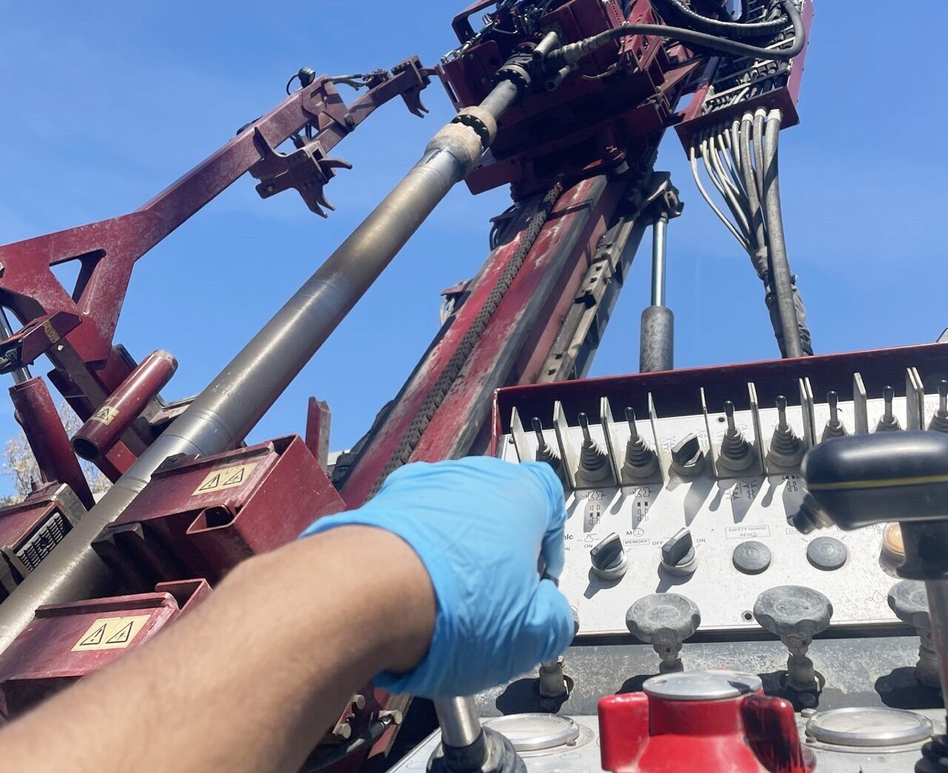

Whether you’re in the field or in the office, you’ll find approachable leaders, open communication, and colleagues who are eager to share knowledge and lend a hand.

Summit is a growing industry leader offering competitive compensation, a 401(K)-retirement plan that includes a generous employer match, healthcare benefits, including dental and vision, a values-based and team-oriented work culture, skills and training development.

We provide employment opportunities company-wide including:
Early Career Apprentice Field Positions
Drilling Positions
Geophysical Services
Remediation Services
Fleet Maintenance & Management
Corporate/Office Administration
Business Development/Sales
So, whether you’re already an experienced licensed professional, a military veteran, or a young person in search of a unique career, Summit offers a proven-effective path to achieve your goals.

We have immediate opportunities for Licensed Drillers and Driller Assistants.
SEARCH ALL JOB OPENINGs on HOOPS >>

Have questions? Reach out to our Vice President of Human Resources, Philip Valensi at 800-424-6648 or email your resume to Employment@SummitDrilling.com

